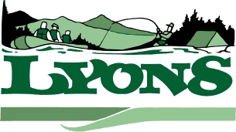 City of Lyons
Phone: 503 859 2167 449 5th Street
Fax: 503 859 5167 Lyons, Oregon 97358

LYONS CITY COUNCIL WORKSHOP MEETING
June 26, 2014

OPEN MEETING: 6:30 P.M.

Present Councilors Mark Orr, Gary Alkire

GUESTS: Brenda Harris, Barbara Orr, Maggie Lunch

Discussion items: No Action Items

Job Duties of City Employees: Guideline that is a living document that will continue to change

Mark Orr suggested that we contract out summer mowing to lighten maintenance duties.

All insurance has been updated.

City ordinance possibly needs to be rewritten to accommodate new city employee positions.

Mark Orr, and Gary Alkire recommends that council sets deadlines for projects that need to be completed.

Accountant proposal needs more information before decision is made, waiting for proposal and will solicit other bids.

Adjourned: 8:00

